**SQL Assignment: All concepts II**

*\*\*Same database file from previous assignment will be used in this assignment. If you haven’t download the first assignment yet follow the instructions:*

**Download the following database file from the link:**

**AirlineDB**: https://drive.google.com/file/d/15ehp3FtyuYqExne3FaFcWHB4TFI_vtSR/view?usp=sharing

**Table structure**

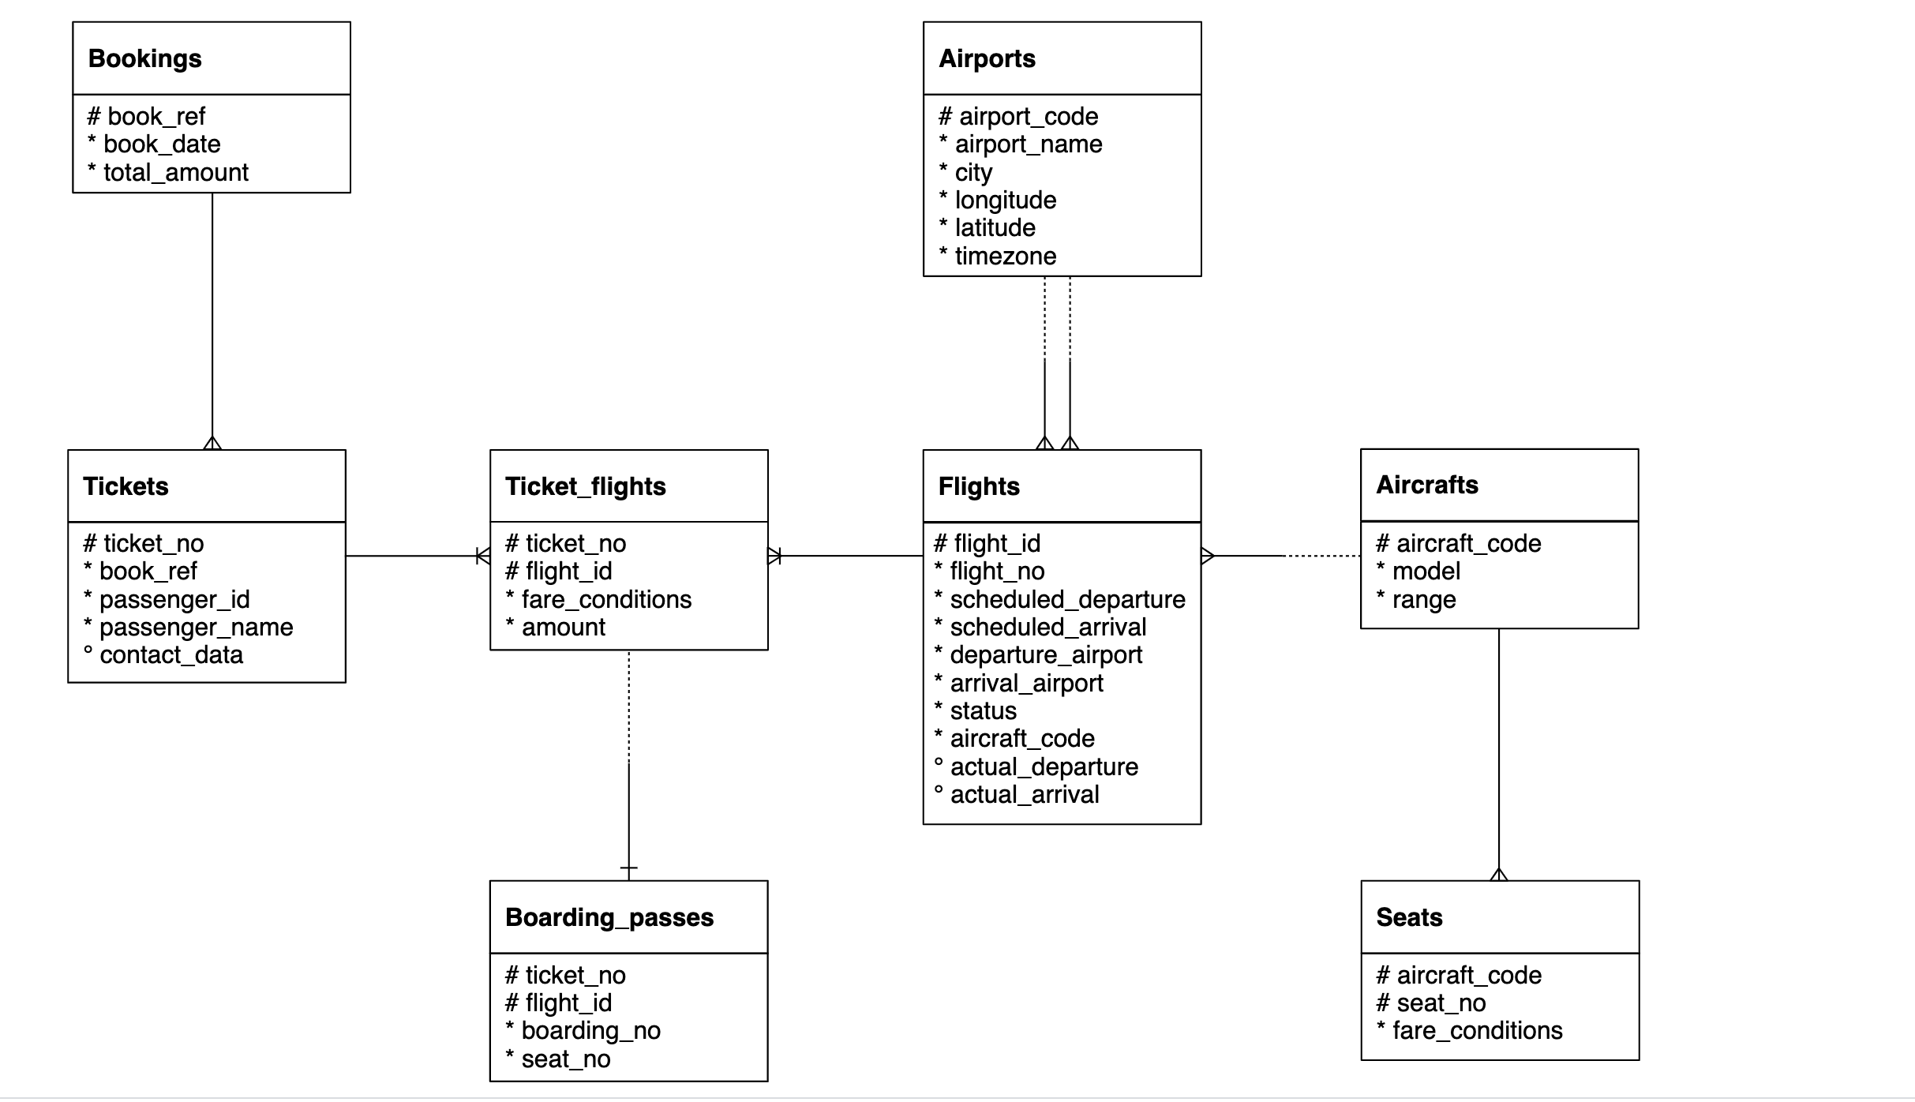

Important Instructions:

* Download the database link and restore in postgres. For restoration, you can refer to the instructions in the first chapter of SQL
* The AirlineDB is quite big in size, hence restoration might take time. Once the restoration starts, wait for 15 to 20 mins and don’t shut down the computer
* Table names in database has “**booking.”** as prefix. For example, bookings.tickets, bookings.boarding_passes. Hence use the prefix in the query as well
  + Correct way of accessing tables: SELECT * FROM **bookings.tickets**
  + Wrong way of accessing tables: SELECT * FROM tickets
* Queries need to be submitted in a **word/text file**. CSV output of the queries will **NOT** be accepted
* Expected output written is written in some of the following question to make sure that you are getting the columns in the same sequence. It doesn’t mean that you will get same values in the output. The exact values in your queries might be different depending on the values sorted in your copy of database.

1. Find list of airport codes in Europe/Moscow timezone.

ANS: Select airport_code from bookings.airports_data

where timezone = 'Europe/Moscow';

1. Write a query to get the count of seats in various fare condition for every aircraft code?

**ANS**: Select aircraft_code, fare_conditions, count(seat_no)

FROM bookings.seats

Group by aircraft_code, fare_conditions;

1. How many aircrafts codes have at least one Business class seats?

ANS: Select count(aircraft_code)

from bookings.seats

where fare_conditions = 'Business';

1. Find out the name of the airport having maximum number of departure flight.

ANS:

1. Find out the name of the airport having least number of scheduled departure flights.

ANS:

1. How many flights from ‘DME’ airport don’t have actual departure?

ANS: Select count(*) from bookings.flights

where departure_airport = 'DME' and actual_departure is NULL;

1. Identify flight ids having range between 3000 to 6000.

ANS: Select count(flight_id) from bookings.flights

where flight_id > 3000 and flight_id < 6000; check please

1. Write a query to get the count of flights flying between URS and KUF?

ANS: Select count(*) from bookings.flights

where departure_airport = 'URS' and arrival_airport = 'KUF'

OR departure_airport = 'KUF' and arrival_airport = 'URS';

1. Write a query to get the count of flights flying from either from NOZ or KRR?

ANS: Select count(*) from bookings.flights

where departure_airport = 'NOZ' OR departure_airport = 'KRR';

1. Write a query to get the count of flights flying from KZN, DME, NBC,NJC,GDX,SGC,VKO,ROV.

ANS: Select count(*) from bookings.flights

where departure_airport IN ('ZN','DME','NBC','NJC','GDX','SGC','VKO','ROV');

1. Write a query to extract flight details having range between 3000 and 6000 and flying from DME.

ANS: Select * from bookings.flights

where flight_id > 3000 and flight_id < 6000

and departure_airport = 'DME';

1. Find the list of flight ids which are using aircrafts from “Airbus” company and got cancelled or delayed

ANS:

1. Find the list of flight ids which are using aircrafts from “Boeing” company and got cancelled or delayed
2. Which airport(name) has most cancelled flights (arriving)?
3. Identify flight ids which are using “Airbus aircrafts”
4. Identify date-wise last flight id flying from every airport?
5. Identify list of customers who will get the refund due to cancellation of the flights? And how much amount they will get?
6. Identify date wise first cancelled flight id flying for every airport?
7. Identify list of Airbus flight ids which got cancelled.
8. Identify list of flight ids having highest range.